SCREENSHOTS KRISHNA B A

**GitHub URL:** <https://github.com/peacefighter/practice-project/blob/main/AngularProject>

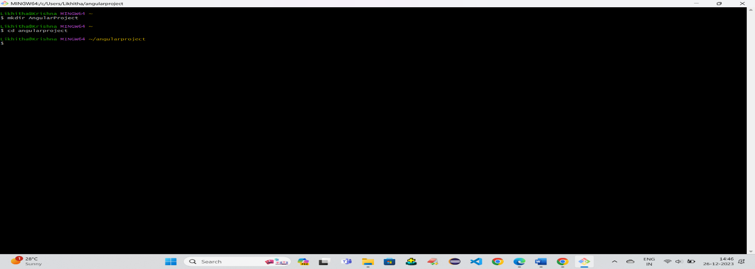Create a Directory:

Add files:

